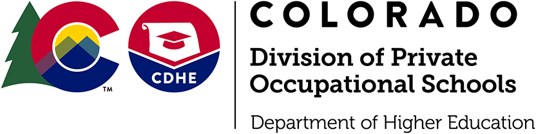
Jared Polis
Governor

Dr. Angie Paccione
Executive Director

Lorna Candler
Chief Occupational Education Officer

Currently ALL schools in Colorado, including Private Occupational Schools are under an Executive Order which prohibits face to face training in the classroom. The Division of Private Occupational Schools has received many inquiries regarding the anticipated date that they can return to face to face training of students. We understand your desire to have some clarity moving forward, and The Division is working closely with Department of Higher Education and the Governor's Office to get further direction. We will continue to notify you as soon as we can of any change to the current Executive Order which would allow schools to resume normal, or semi normal operations.

